Department of Computer Science and Engineering (Data Science)
CSDS-A | Batch A3 (CSE - Data Science, Section A)
A Dynamic Phishing URL Detection System Integrating Advanced Machine Learning and Crowdsourced Threat Intelligence
(PhishGuard)
S.No. | Student name | Roll / hall ticket no.
1 | D.ANISH MEGHAN | 23K91A6750
2 | B.AKSHAYA | 23K91A6737
3 | B.TANUJA | 23K91A6736
4 | CH.SAI CHETHAN | 23K91A6742
Under the guidance of: Mr. G. Ravi, [DESIGNATION]
BLOCK DIAGRAMS
This document collects every design diagram of PhishGuard. Each diagram was drawn from the real code and database schema and is followed by a paragraph that explains it. The diagrams were generated by scripts/make_diagrams.py with matplotlib.
Table 1: Diagrams in this document
No. | Diagram | Shows
1 | System architecture | Layers: users, React front end, Flask API and modules, local storage
2 | High-level workflow | From dataset to a self-refining detector
3 | DFD level 0 | Context: PhishGuard and four external entities
4 | DFD level 1 | Seven processes and five data stores
5 | DFD level 2 | Expansion of the check path
6 | Use-case diagram | Actors and their use cases
7 | Sequence diagram | Check, report and retrain
8 | ER diagram | Three SQLite tables and three file stores
9 | UML class diagram | Classes and modules of the Python package
10 | Algorithm flowchart | Decision order of the detector

1 System Architecture
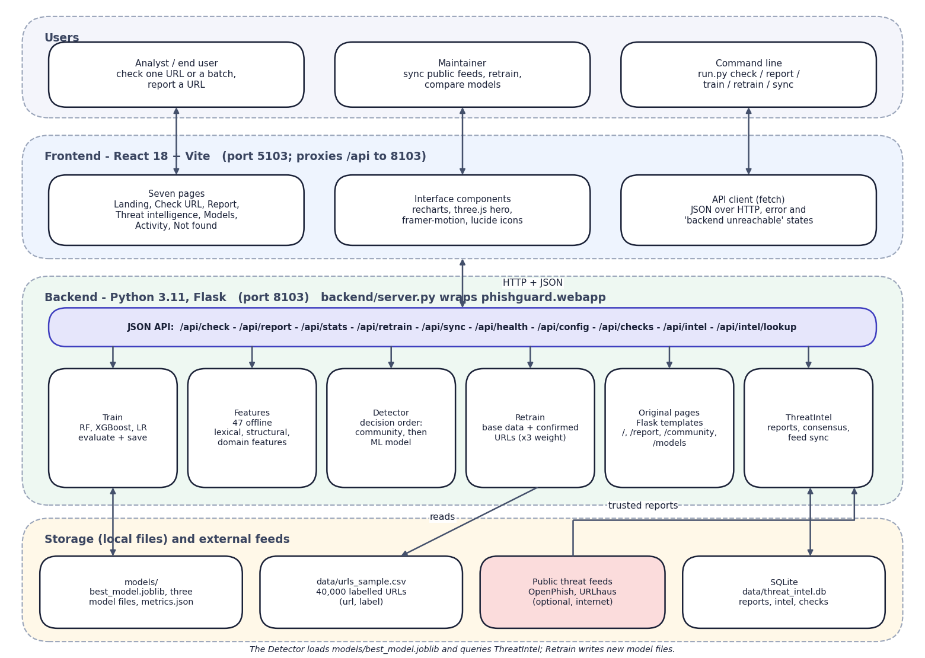
Fig. 1: System architecture of PhishGuard
The architecture has four layers. Users reach the system through the React interface on port 5103 or the command line. The Vite dev server serves the seven pages and proxies every /api call to the Flask application on port 8103, so the browser talks to one origin. backend/server.py wraps the original Flask application (phishguard.webapp) without changing it and adds five read-only JSON endpoints and the CORS header.
Behind the API are six modules. Features turns a URL into 47 numbers; Detector applies the decision order; ThreatIntel stores reports and computes consensus; Train fits and compares the models; Retrain merges confirmed URLs into the training data; and the original pages module keeps the first Flask interface alive. Storage is local: the SQLite file threat_intel.db, the model files and metrics.json, and the dataset CSV. The two public feeds are the only external systems, and they are optional.

2 High-Level Workflow
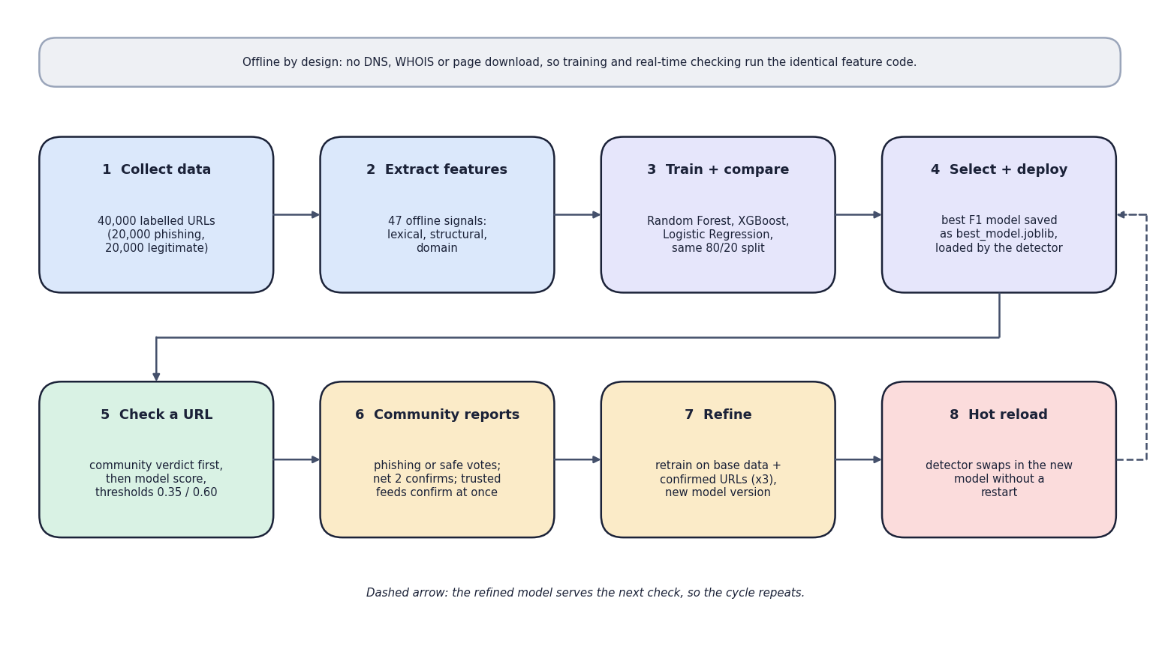
Fig. 2: High-level workflow: from dataset to a self-refining detector
The workflow has two halves. In the upper row the system is prepared once: the 40,000-URL dataset is loaded, 47 features are extracted, the three classifiers are trained and compared on the same split, and the best by F1 is saved and loaded by the detector. In the lower row the system is used and improved: a URL is checked, the community reports it, confirmed URLs retrain the models, and the detector hot-reloads the new model. The dashed arrow shows that the refined model serves the next check, so the cycle repeats.
The note at the top records a design choice that makes the loop practical: all features are computed offline from the URL string, so the code that extracts features for training is identical to the code that runs at check time.

3 Data-Flow Diagram: Level 0
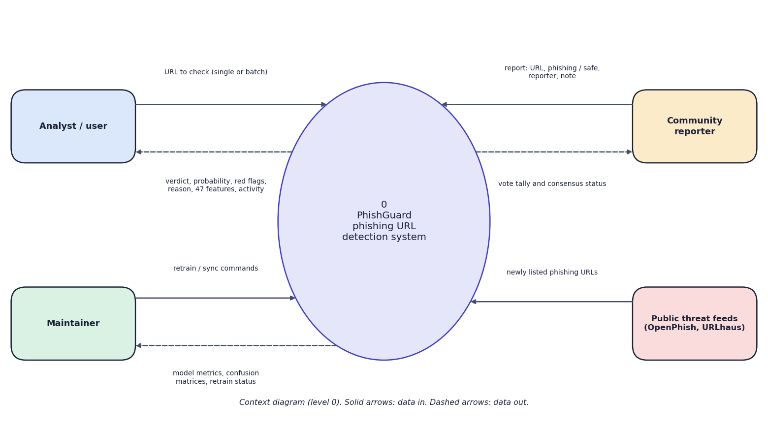
Fig. 3: Data-flow diagram, level 0 (context)
The context diagram shows PhishGuard as one process and four external entities. The analyst sends URLs and receives verdicts, probabilities, red flags and the activity log. The community reporter sends reports (URL, phishing or safe, reporter, note) and receives the vote tally and status. The maintainer sends retrain and sync commands and receives metrics and retrain status. The public threat feeds supply newly listed phishing URLs. The analyst and the reporter are often the same person; they are drawn separately because they use different pages.

4 Data-Flow Diagram: Level 1
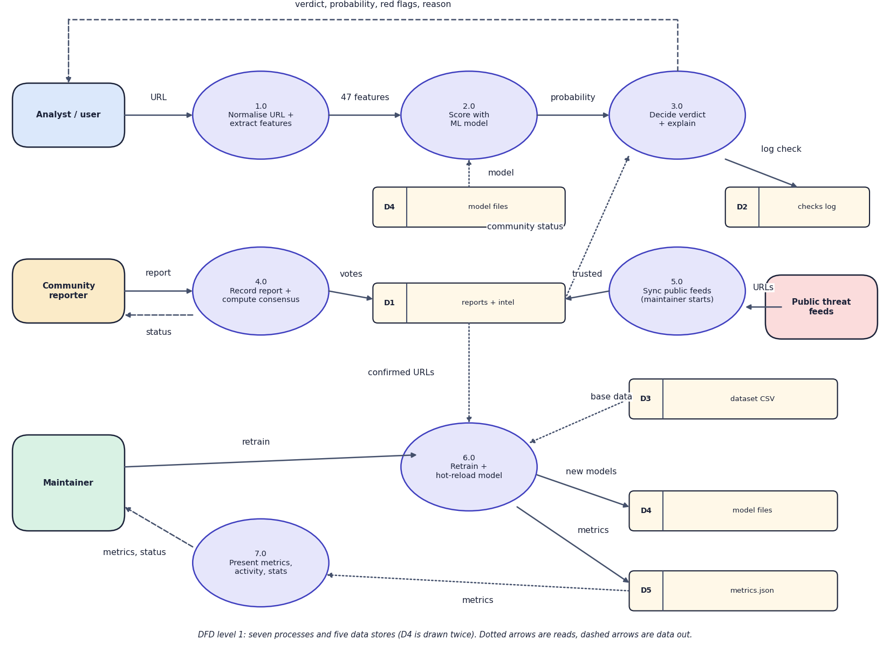
Fig. 4: Data-flow diagram, level 1
Level 1 splits the system into seven processes and five data stores. Processes 1.0 to 3.0 form the check path: the URL is normalised and turned into features, scored by the model loaded from D4, and combined with the community status from D1 to give the verdict, which is logged in D2. Process 4.0 records a report and computes consensus in D1. Process 5.0 imports feed URLs as trusted reports. Process 6.0 reads confirmed URLs from D1 and the base data from D3, retrains, and writes new models to D4 and metrics to D5. Process 7.0 presents the metrics, activity and statistics to the maintainer. D4 is drawn twice only to keep the lines short.

5 Data-Flow Diagram: Level 2
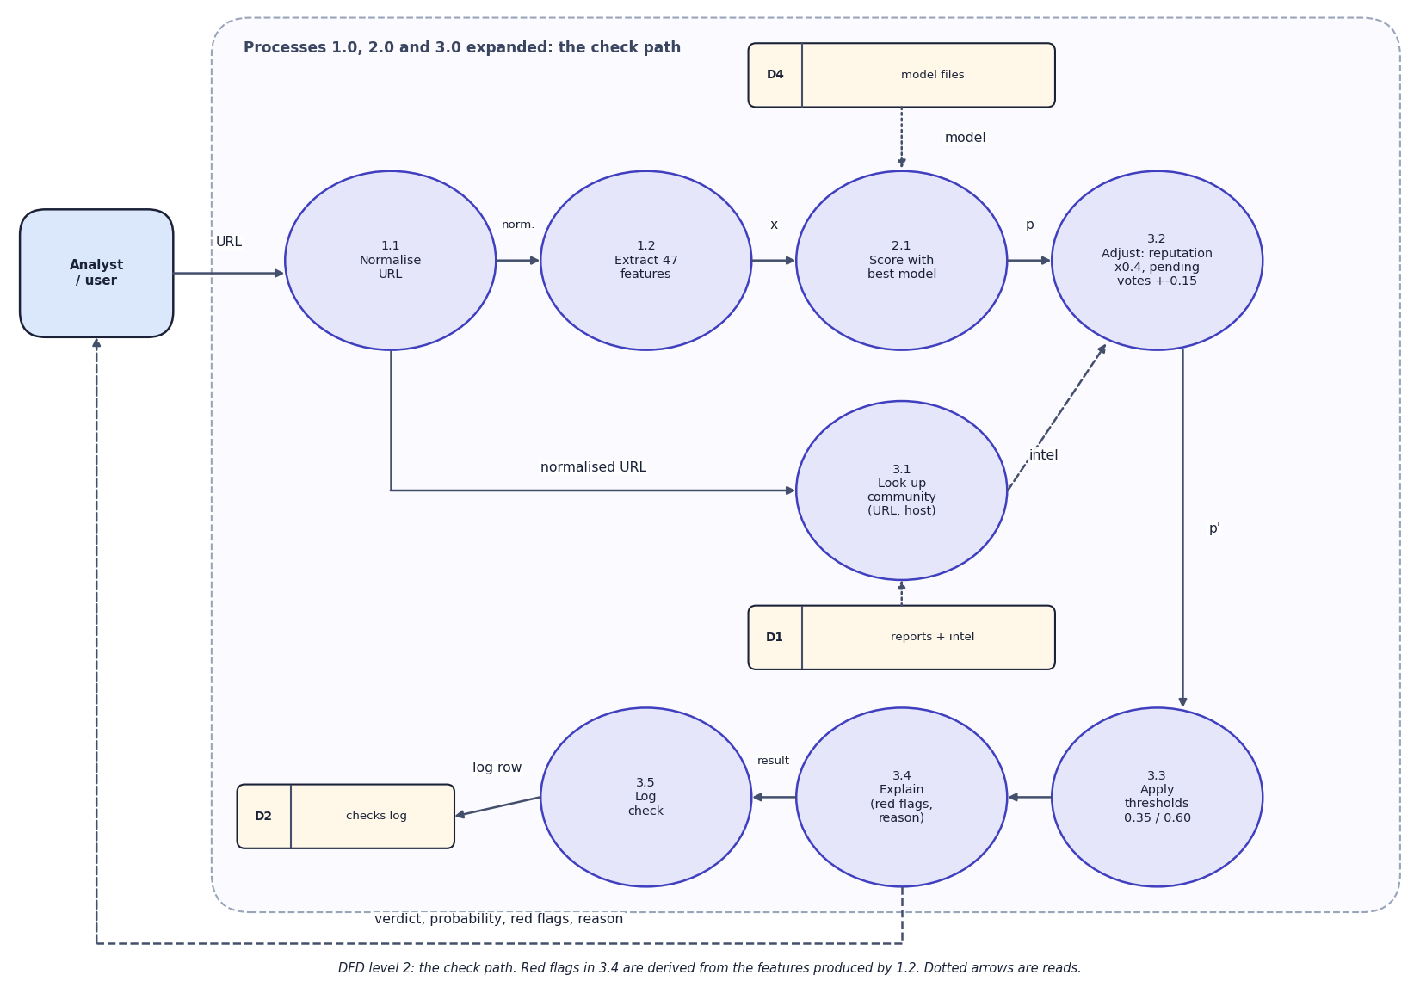
Fig. 5: Data-flow diagram, level 2 (the check path)
Level 2 opens the check path. 1.1 normalises the URL (scheme, lower-case host, no www.). 1.2 extracts the 47 features. 2.1 scores them with the best model. 3.1 looks up the community store for the URL and for its host. 3.2 applies the reputation discount (x0.4 for well-known registered domains) and the pending-vote adjustment (+/-0.15 per net vote). 3.3 applies the thresholds 0.35 and 0.60. 3.4 builds the red flags and the reason text from the features. 3.5 writes a row to the checks log. A confirmed community verdict skips 2.1 to 3.3, as the flowchart shows.

6 Use-Case Diagram
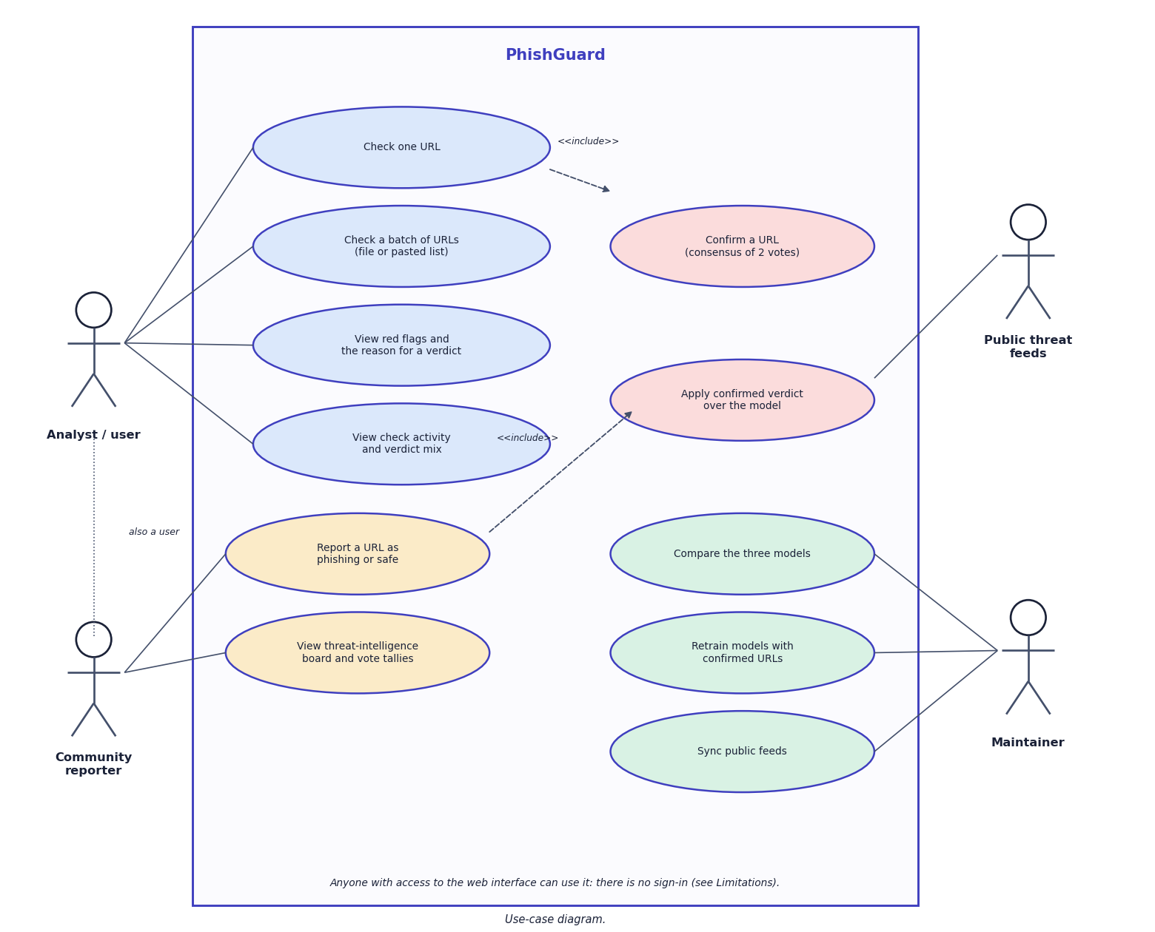
Fig. 6: Use-case diagram
The use-case diagram has four actors. The analyst checks a URL or a batch, reads the red flags and the reason, and reviews the activity log. The community reporter reports a URL and views the threat-intelligence board; reporting includes confirmation by consensus. Checking a URL includes applying a confirmed verdict over the model. The maintainer compares the models, retrains them and synchronises the public feeds, and the feeds themselves act on the confirmation use case. The note records that there is no sign-in, so any user can act in any role.

7 Sequence Diagram
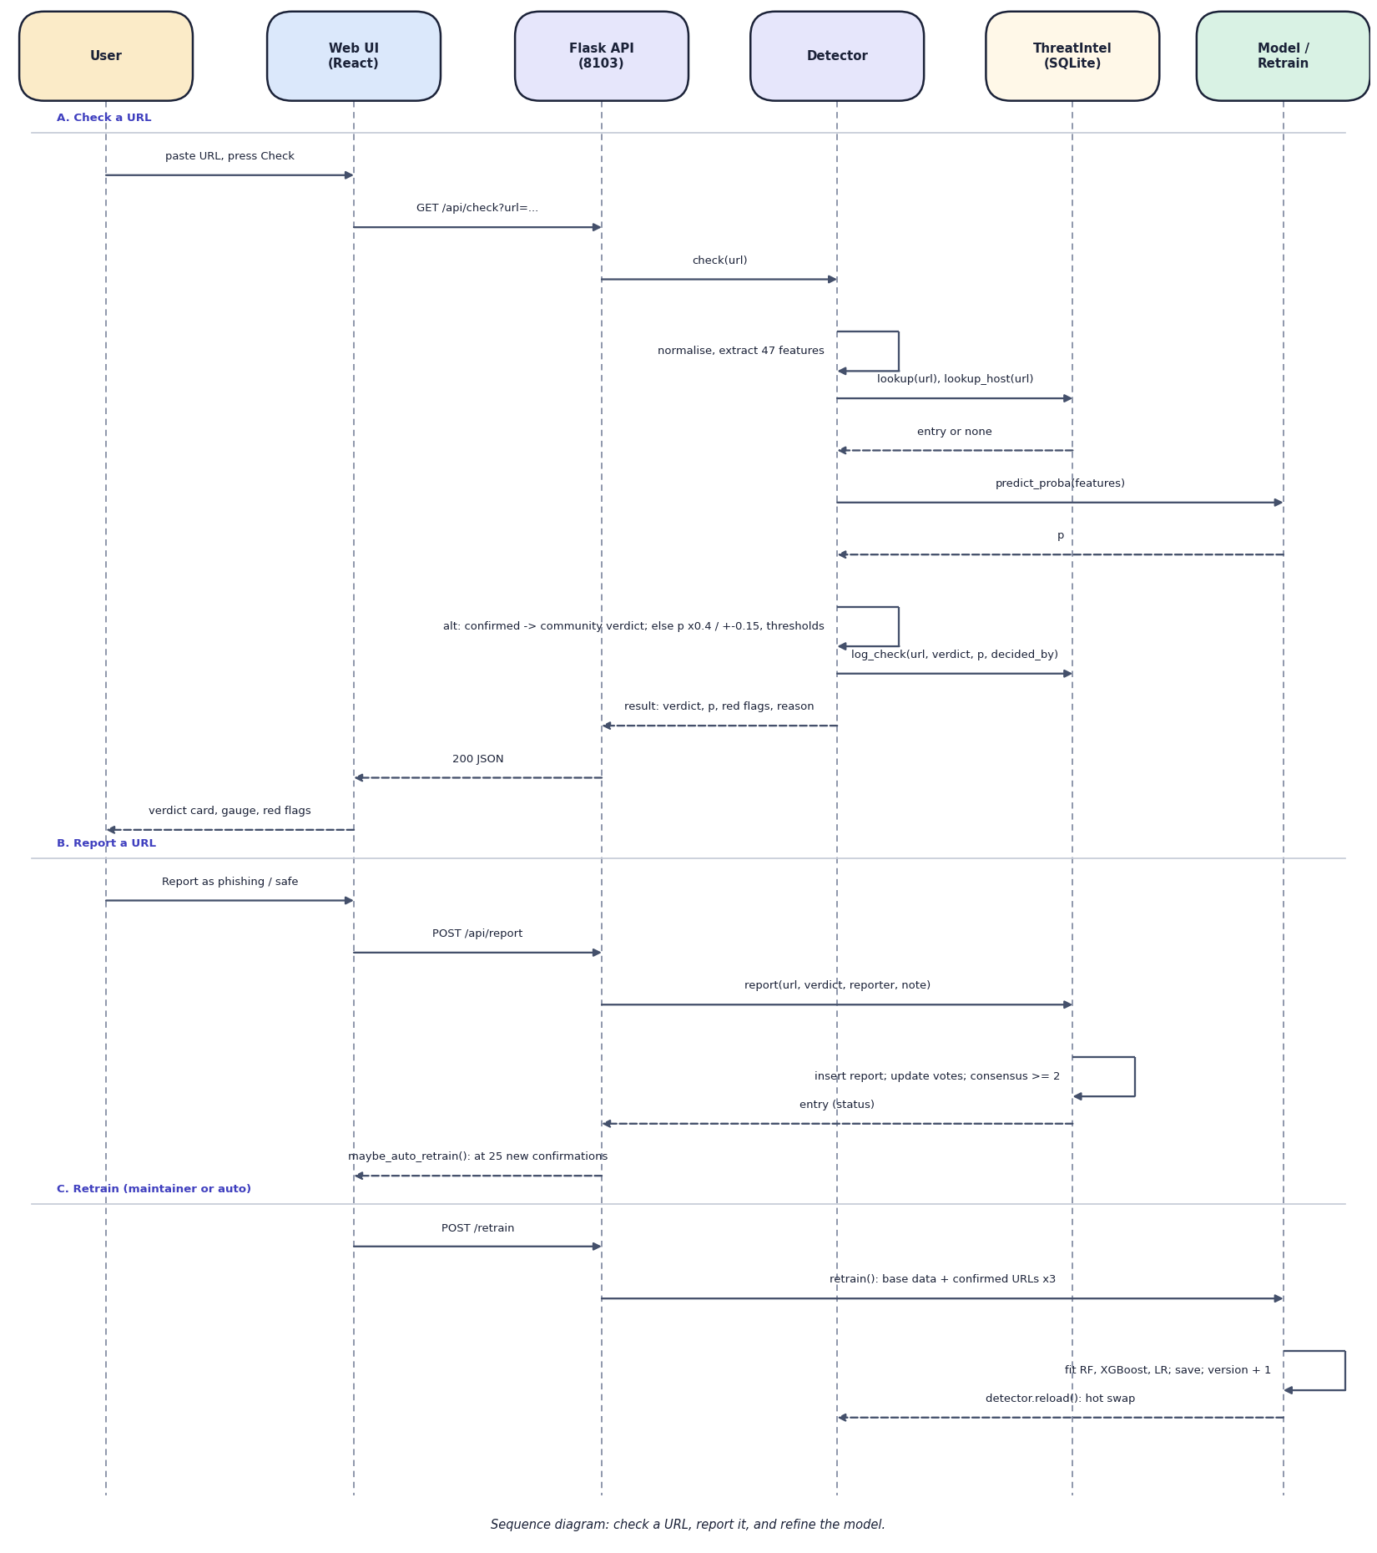
Fig. 7: Sequence diagram: check a URL, report it, refine the model
The sequence diagram has three parts. In part A the user presses Check; the React page calls GET /api/check; Flask asks the Detector, which extracts features, queries ThreatIntel for the URL and its host, asks the model for a probability, applies the decision rules, logs the check and returns the result. In part B a report is posted, ThreatIntel inserts it, updates the vote counts and recomputes consensus, and the API may start an automatic retrain after 25 new confirmations. In part C a retrain fits the three models, bumps the version and tells the Detector to reload the best model.

8 Entity-Relationship Diagram
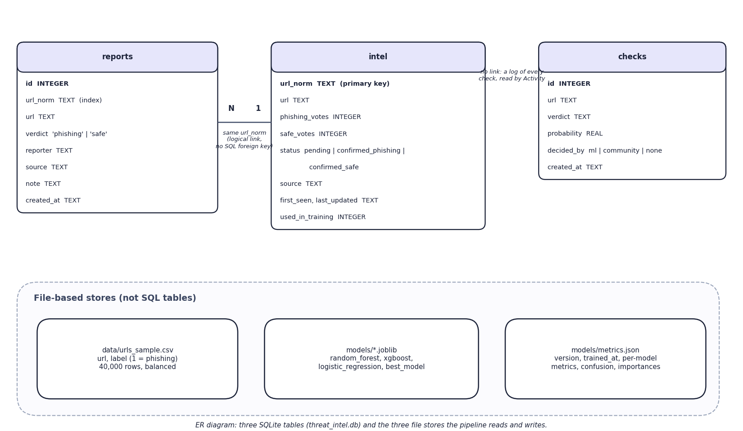
Fig. 8: Entity-relationship diagram
The database has three tables in threat_intel.db. reports stores every individual report (URL, verdict, reporter, source, note, time) and is indexed on the normalised URL. intel holds one row per normalised URL with its phishing and safe vote counts, its status (pending, confirmed_phishing or confirmed_safe), its source, first-seen and last-updated times and a flag showing whether it has been used in training. checks is an append-only log of every verdict. reports and intel are linked logically by the normalised URL; the schema declares no SQL foreign key. The lower panel shows the three file-based stores that the pipeline reads and writes.

9 UML Class Diagram
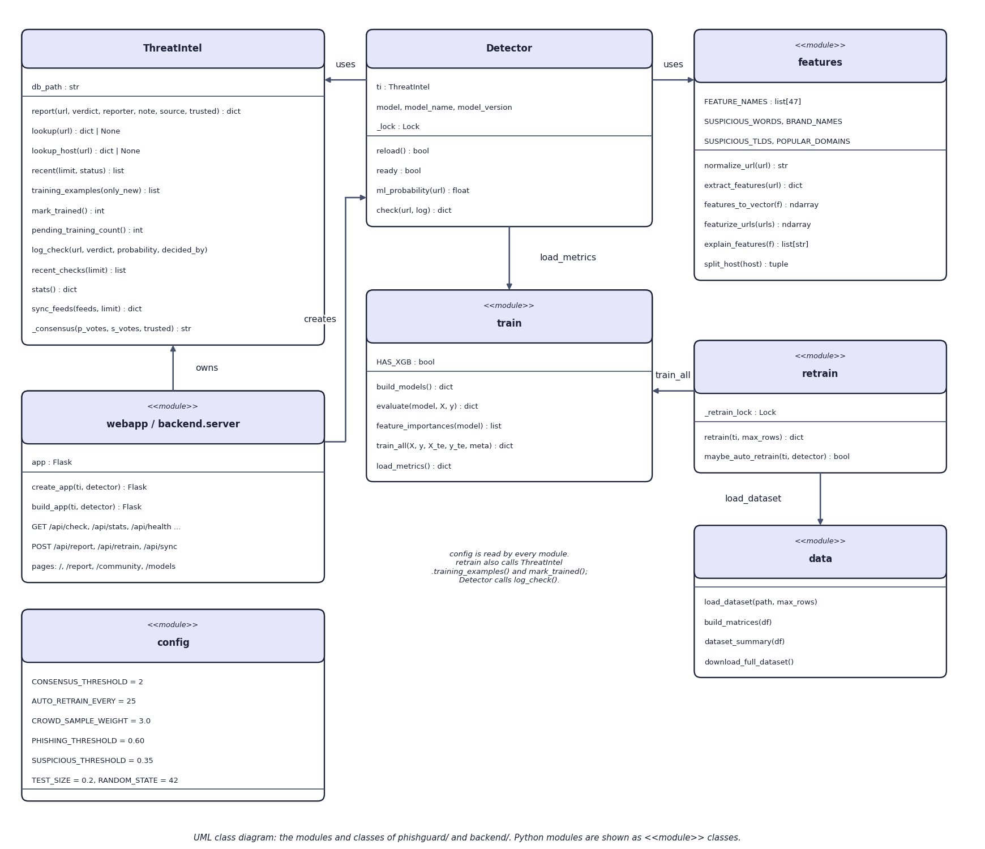
Fig. 9: UML class diagram of the Python modules
The class diagram shows the Python structure. ThreatIntel is the only real class with state (the database path). Detector holds a ThreatIntel, the loaded model, its name and version, and a lock that protects the model while it is swapped. features, train, retrain, data and config are modules of functions and constants, drawn as <<module>> classes. webapp and backend.server create the Flask application and call Detector.check. retrain calls train_all and load_dataset, and uses ThreatIntel's training_examples and mark_trained.

10 Flowchart of the Core Algorithm
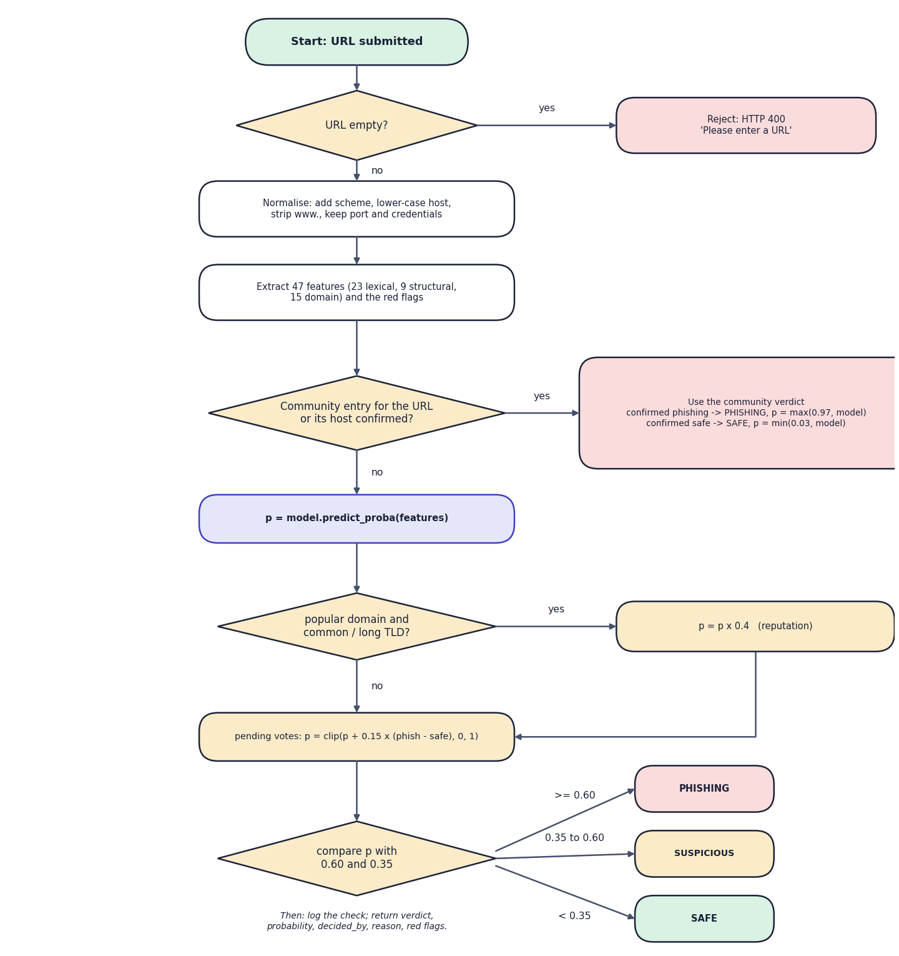
Fig. 10: Flowchart of the core algorithm (decision order of detector.check)
The flowchart is the decision procedure of Detector.check. An empty URL is rejected with HTTP 400. Otherwise the URL is normalised, 47 features and the red flags are extracted, and the community store is queried for the URL and for its host. A confirmed community entry decides at once: confirmed phishing gives probability max(0.97, model) and confirmed safe gives min(0.03, model). Otherwise the model produces p; a well-known registered domain multiplies p by 0.4; pending votes add 0.15 per net vote; and p is compared with 0.60 (phishing) and 0.35 (suspicious). Every outcome is logged and returned with its reason.

